5 Strategies in IT recruitment

If you are a tech organization or a recruitor you may know that hiring IT people like front, back-end and full-stack developers is very different from traditional roles.
Especially for start-ups, a couple of bad hires could get expensive very fast.
The following are the five strategies that could help you get good hires.

Strategy #1: Source passive candidates from social media

Social media is nowadays a common and effective way to source passive candidates. Passive candidates are those who are not looking for a job at the moment or are too busy to look for one themselves.
Primarily they work at top companies and have good technical skills.
These are the prime candidates that everyone wants to hire and contacting and getting their interest is a challenge in itself.
Some good ways to contact them include Linkedin, Facebook & Twitter. For example, for a small fee, Linkedin gives you access to a candidate’s inbox.


Fig 1: Linkedin inmail example to probe candidate’s interest

Strategy #2: Seek social proof

In your search for the best fit you could have a look at what your prospects are posting on Stackoverflow (A technical questions & answers site like Quora) to understand their reputation and rank in the hacker community.
And with some knowledgabe of GitHub, you could also have a look at their code repositories to see if they have posted useful code that has been forked & starred many times.

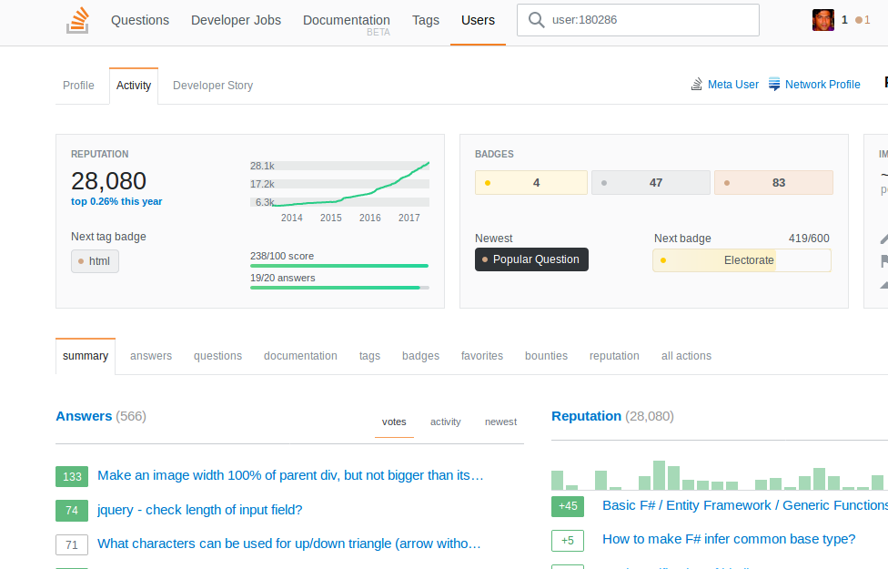
Fig 2: Stackoverflow profile page showing a candidate’s reputation & scores

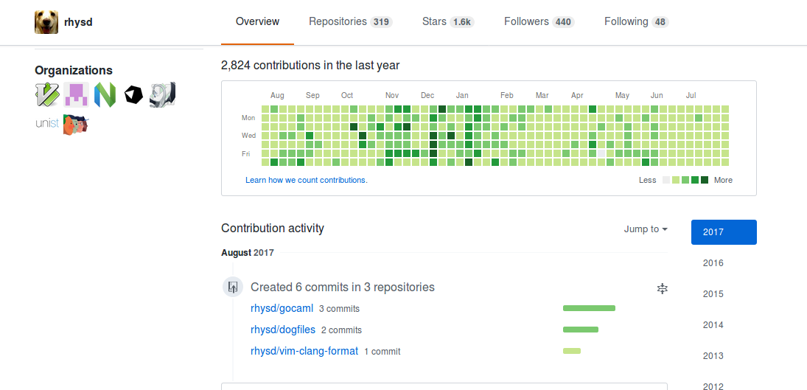
Fig 3: GitHub profile page showing a candidate’s commit information for variois projects.

Strategy #3: The test assignment

Finally your prospect has expressed interest in your position.
If you are knowledgable techie yourself or have a techie in your team, you could give him a technical or coding exercise to test his skills.
You could also use third-party services like HackerRank which specializes in creating & grading assignments over their Saas service.
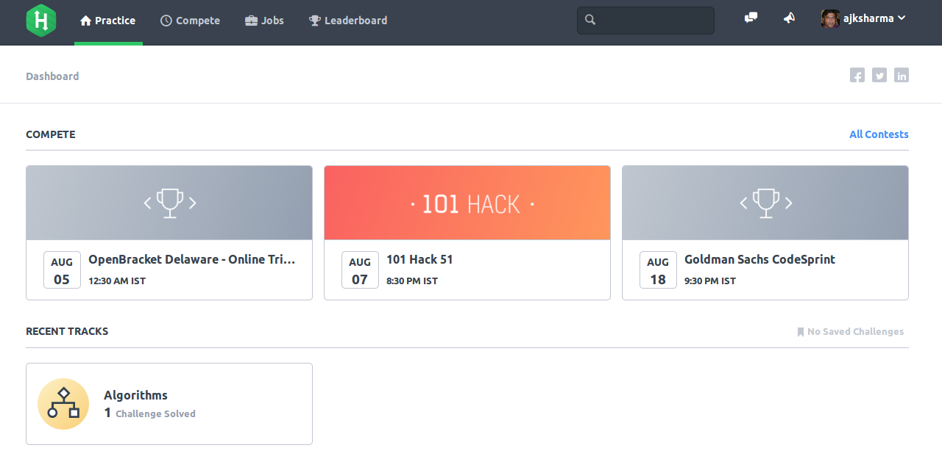
Fig 4: HackerRank contests & challenges to test a candidates skills & knowledge
HackerRank is now integerated with many ATS like Lever & Greenhouse.

Strategy #4: Remote Jobs

Man companies are now offering full or partial remote jobs.
If it fits your culture, your offer may appeal to a growing number of talented hackers who don’t want to move or are digital nomands who are always on the move in various parts of the world.
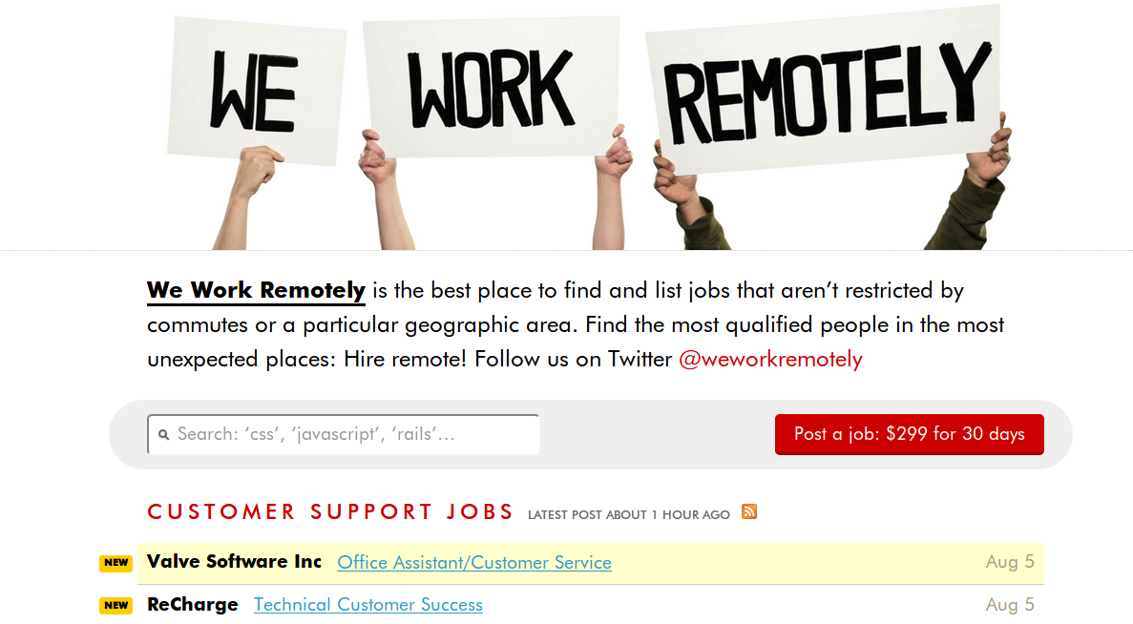
Fig 5: Many job sites have sprung up to server the remote worker

Strategy #5: Outsource!

Another option would be to outsource the whole process to specialists who specialize in technical recruiting.
Companies like Triplebyte do the initial screening and technical interview themselves, leaving you to take a decison on the final step.

Fig 5: Triplebute: disrupting the recruiting scene with the personal touch

Hit the comments section to post you views!

